September 2019
Dear Elmhurst Academy Parents and Families,

Elmhurst Academy uses the directory, DirectorySpot, for our online school/family directory. Parents are able to access the directory on the Web by visiting: www.directoryspot.net, or right from a smartphone via the DirectorySpot app.

The app contains parent names, home phone number, home address, parent email addresses, parent cellular phone numbers and student names. The app is very secure and only parents and staff of Elmhurst Academy will be granted access. Each user will logon with their authorized email address and will set their password. If you would like more information on the security features, please follow this link at: https://www.directoryspot.net/security.php

If you are new to Elmhurst Academy or haven’t signed up for DirectorySpot yet, please complete the attached information and return it to the school mailbox. This information can also be found on the main page of our website at: www.elmhurstacademy.com.

Once all of the data is loaded, you will get an email with instructions on how to download DirectorySpot and set your password. **You are not required to sign up with DirectorySpot each year. Your information will stay in the system as long as your child is enrolled at Elmhurst Academy.**

You have full access to your own data and can update your information at any time throughout the year.

Here are some screenshots from the app (data is fictional):

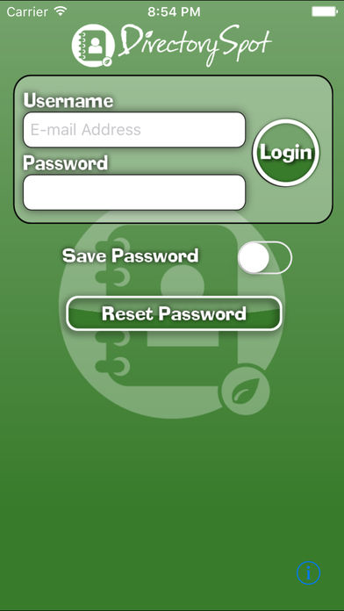
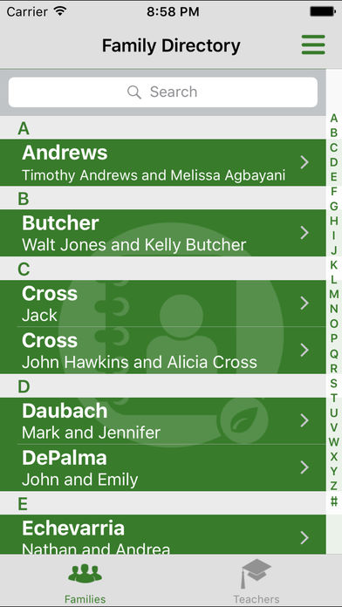
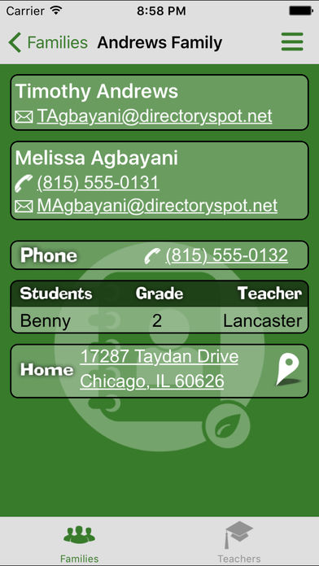

The app uses iPhone and Android technology, so you can call, text, or email other parents or teachers with one click, right from the app. We hope you will enjoy Elmhurst Academy’s new Parent/School Directory “On the Go.”

Elmhurst Academy
DirectorySpot
2019-20 School/Family Directory

_____ Yes! Please include my family information in the 2019-20 Elmhurst Academy DirectorySpot.

Student Name: __________________________________________________________

Classroom: ______________________________________________________________

Parent name: ___________________________________________________ Mother Father

Parent Email Address: _____________________________________________ Mother Father

Parent Cell Phone Number: ________________________________________ Mother Father

Parent name: ___________________________________________________ Mother Father

Parent Email Address: _____________________________________________ Mother Father

Parent Cell Phone Number: ________________________________________ Mother Father

Home Address: _____________________________________________________________

City: ______________________________ State: ________ Zip Code: _________________

Home Phone: ______________________________________________________________

Please complete additional forms for each child enrolled at the academy.

____ I wish to opt-out of the 2019-20 Elmhurst Academy DirectorySpot.

Parent Signature: ________________________________________ Date: _______

Please submit form to the EA mailbox.
Elmhurst Academy, 212 West Lake Street, Elmhurst, Illinois 60126

